FINAL EXAMINATION . TIME ALLOWED: 90’ .
Subject: Linear Algebra. No books allowed.

1/ Find the matrix , such that 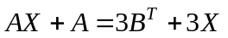, where 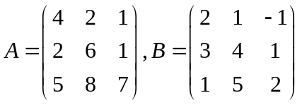.

2/ Determine all real values of m, given that the matrix 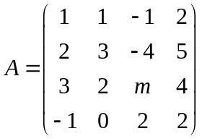 is invertible.

3/ Solve the linear system of equations AX = b, given that
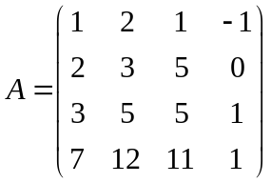 and 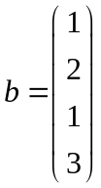

4/ In 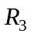 with the inner product , given the subspace .
Find one basis and a dimension of the orthogonal compliment 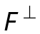 of the subspace F.

5/ Let 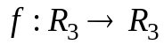 be the linear transformation. Given that 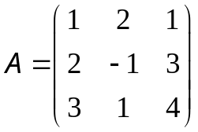 be the matrix of the linear mapping f in the basis: 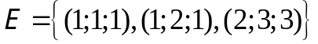.
a/ Compute 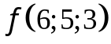.
b/ Find one basis and a dimension of the image of the mapping 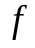.

6/ Let 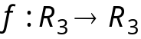 be a linear transformation.
Assume that

Find the matrix  of the linear transformation f in the basis 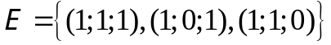.

7/ Compute 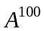, where 

  

